Australia webpage

Important considerations:
- Hidden from Navigation
- url - https://www.venterra-group.com/what-we-do/australia/

Headline
Powering Australia’s Offshore Wind Future

Introduction
With decades of global expertise and a proven track record across the full lifecycle of offshore wind projects, we support governments, state agencies, and Tier-1 developers through every phase of wind farm development.
By leveraging our world-class capabilities, Australia can accelerate its offshore wind ambitions, attract the necessary investment, and establish itself as a leader in the global renewable energy transition.
Image: https://www.dropbox.com/scl/fo/iybz22d27shbnk9i1nr2g/AIaBy3pxGyhQLRfgkae1yqM/venterra-images?preview=OWF+Photo.jpg&rlkey=1u455h516uh9c8zu63ixspqr5&subfolder_nav_tracking=1&st=enkfk3s0&dl=0
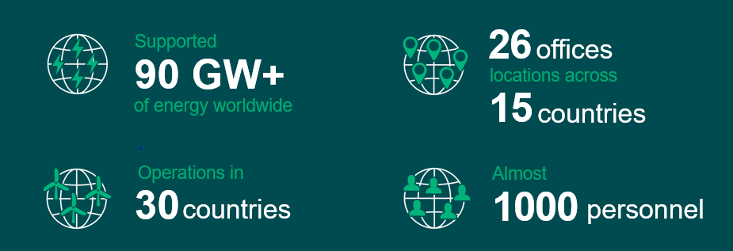

Insights
Presentations from Event (awaiting final pdfs)
- Early-Stage Advisory Best Practice for Offshore Wind
- Early-Stage Lessons Learned: Non-extractive Benthic and Fisheries Surveys
- Early-Stage Lessons Learned: Metocean and Site Investigation Surveys
- Global Lessons Learned: EIAs
- Global Lessons Learned: Marine Acoustics
- Early-Stage Lessons Learned: UXO and Geosciences
- Global Lessons Learned: Design and Nature Based Design

Sediment profile Imaging/Plan View Surveys: Why Spi? - https://vimeo.com/1028942268
Data Visualisation: Pop up Maps - https://vimeo.com/704690781
Story Maps – link tbc
Webinar: Global Best Practices for Early Stage Offshore Wind Development
- https://vimeo.com/1039714389/0f5c602e00?share=copy
How Venterra can support you - https://vimeo.com/1038933865/31afc597e9?share=copy

Services
Engineer, Build, Support – as per the carousel on the below page
https://venterra-group.com/what-we-do/

Get in Touch
As per the below page, with the email address edited to - anntonette.alberti@venterra-group.com
https://venterra-group.com/what-we-do/engineer/environmental/

